A Sophisticated New Menu Set to Delight Discerning Palates introduced by Jamie Oliver Kitchen Kuta Beach, Bali.

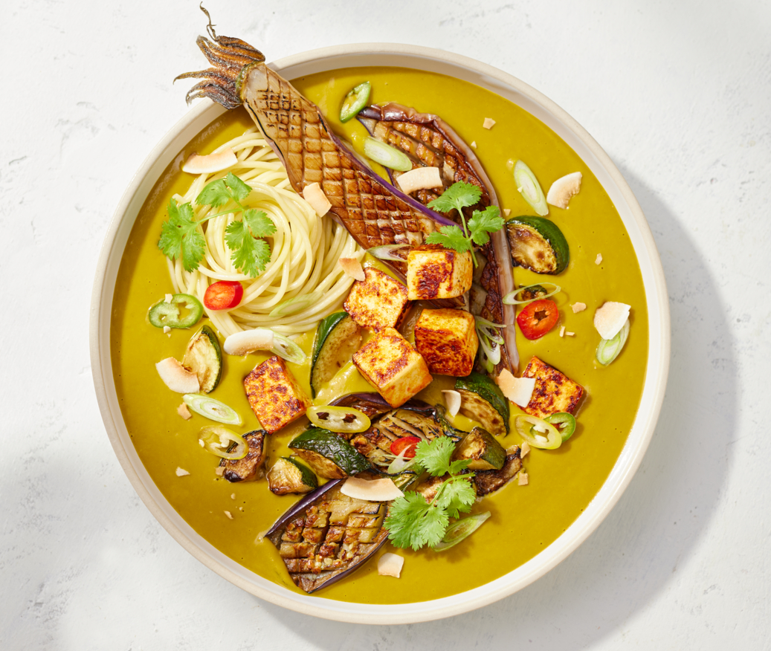
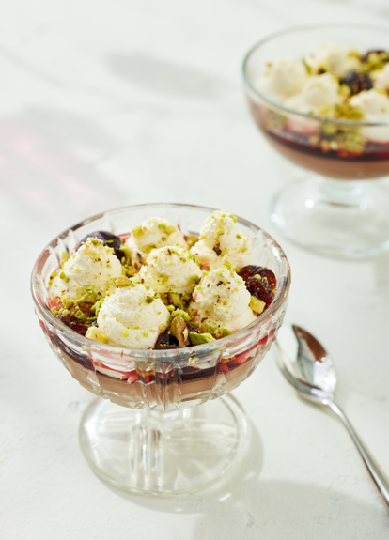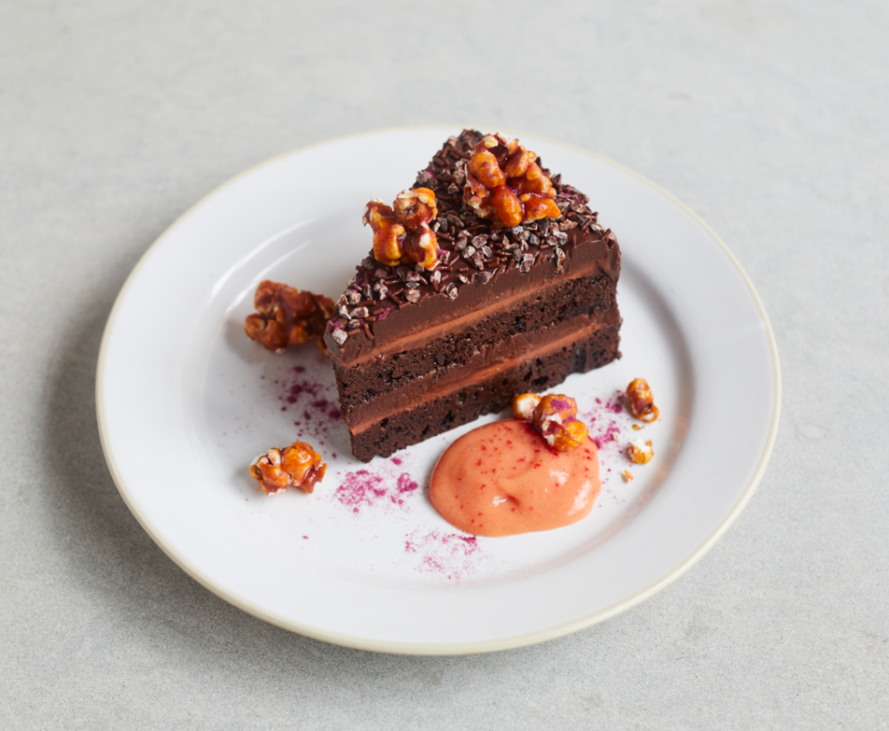

Kuta, December 15th, 2023. Jamie Oliver Kitchen Kuta Beach is delighted to announce the launch of its new menu on December 15th, 2023. This represents the second culinary innovation from Jamie Oliver Kitchen this year, underscoring a dedication to providing diverse and refined dining experiences. Highlighted as one of the star attractions on the revamped mains menu is “Jamie’s Veggie Laksa”, a tantalizing blend of tender roasted aubergine & courgette, spicy paneer & noodles enveloped in a spiced squash and coconut sauce. Complemented by spring onions, chilli and coriander. Also gracing the menu is the sumptuous “Mushroom Stroganoff”, a velvety mushroom stew served with fluffy rice, cornichon & caper gremolata, providing a comforting and opulent dining experience. And the “Nori Salmon” brings a delightful fusion with herby tartare sauce, minted mushy peas, shoestring fries and a sprinkle of nori. Not to be missed, is the latest addition to the burger lineup – the Katsu Chicken Burger. Featuring crispy crumbed chicken, curry mayonnaise, zingy slaw, and pickles, it’s a flavorful twist on a classic favorite.

For those with a sweet inclination, the dessert menu showcases irresistible creations destined to be on every epicurean’s must-try list. “Mocha Mousse” beckons with its airy chocolate and coffee ganache, accompanied by Chantilly cream, sticky cherries and pistachios. Meanwhile “Jamie’s Brigadeiro Cake” presents a lush combination of chocolate sponge, condensed milk and cocoa ganache, complemented by guava jelly and acai-caramel popcorn.

“We are thrilled to introduce our new menu, crafted with passion and precision to elevate the dining experience at Jamie Oliver Kitchen. Each dish is a celebration of flavors, textures, and culinary artistry, reflecting Jamie Oliver’s commitment to bringing joy to food enthusiasts. In a commitment to inclusivity, more than half of the menu is crafted with delightful vegetarian options and being a pork-free establishment, ensuring a welcoming space for customers with diverse dietary needs. This approach embraces inclusivity, catering to the preferences of wide-ranging guests to indulge in super-fresh Jamie Oliver’s culinary creations,” remarked Erickson Hutagaol, Restaurant General Manager at Jamie Oliver Kitchen.

Do not miss the opportunity to embark on a gastronomic journey with Jamie Oliver Kitchen’s latest offerings. Whether you are a devoted fan or a first-time visitor, the new menu promises a sensory feast that will undoubtedly leave you yearning for more.

-ENDS-

About Jamie Oliver Kitchen Kuta Beach
Jamie Oliver Kitchen offers all-day eating at its best. From the ultimate in comfort food or super-tasty, healthier choices, they cover all the bases with a whole host of enticing, tempting dishes, using only the best ingredients. Located just a stone's throw away from the famed Kuta Beach, Jamie Oliver Kitchen sits in the heart of Bali's prime entertainment and shopping district.

“Our eclectic, flavourful menu tells the exciting story of Jamie’s journey through food. We celebrate his favourites from over the years and acknowledge each restaurant’s location by playing on local ingredients and flavour profiles. We invite our guests to share Jamie’s global adventures”
For more information, please contact:
Jamie Oliver Kitchen Bali
Jalan Pantai Kuta, Banjar Mas Pande, Kuta
+62 361 762 118
https://www.jamieoliverkitchen-id.com/en/bali/

Ratna Budiarti
Marketing Communication Manager, Hard Rock Hotel Bali
Tel : +62 (361) 761869
Mobile : +62811 3800 1545 / +6281 855 9894
E-mail : ratna.budiarti@hardrockhotels.net

A.A Mirah Saraswati
Assistant Marketing Communication Manager, Hard Rock Hotel Bali
Tel : +62 (361) 761869
Mobile : +62 812 3801 9378
Email : mirah@hardrockhotels.net

